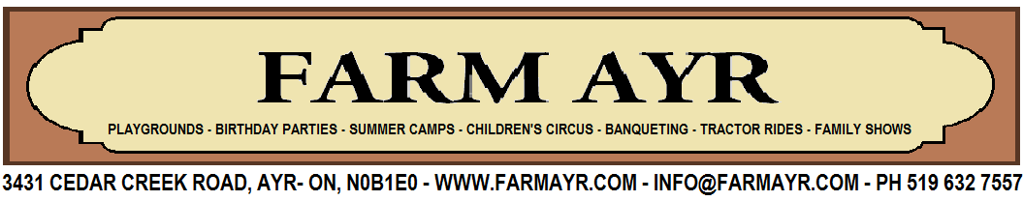

Farm & Circus Week Summer Camp Registration

Date: July 15 to July 19 - 2019, 9am to 4pm
1 Registration - $235 incl. H.S.T. per child - 2 registrations: $ 225 incl. H.S.T. per child
Before (8am to 9am) & aftercare (4pm to 6pm) available for $8 incl. H.S.T. per hour
Please note: Registration and full payment must be received by February 28
___________________________________________________________________________________________
Student 1 - Name: ________________________Date of Birth: ________ Age: ___
Physical Limitations: _________________________________________________
Allergies: ______________________________Health Card No: ______________
____________________________________________________________________________________________
Student 2 - Name: _______________________Date of Birth: _________ Age: ___
Physical Limitations: _________________________________________________
Allergies: ______________________________Health Card No: _______________
__________________________________________________________________

Mother’s Name: ___________________Father’s Name: ______________________
Address: ________________________ City: ________________Code: _________
Telephone # Home: _____________________Cell: _________________________
Work: _____________________ E Mail: __________________________________
How did you know about us? ___________________________________________
__________________________________________________________________

PAGE 1

PAYMENT

Student 1 - $235…………………………………………………………….$ 235.00
Student 2 - $225…………………………………………………………….$ _______
After hours care Weekdays and times: ______________________________________________________
_____________________________________@ CAD 8.00 per hour: $________
TOTAL AMOUNT (H.S.T. included)…………………………………….. $________

Please send cheque (made out to Tours & Events Unlimited Inc.) to:
Farm Ayr, 3431 Cedar Creek Road, Ayr ON, N0B1

PLEASE READ AND SIGN THE FOLLOWING INDEMNITY CLAUSE
I hereby assume all of the risks arising out of, incidental to, or in any other way connected with my or my child’s participation in the summer camp provided by Tours & Events Unlimited Inc. T/A Farm Ayr and its teachers or agents, including but not limited to any risks which are not foreseeable.
I hereby release Farm Ayr and all its officers, directors, employees, including teachers and supervisors from any and all liability and any and all claims arising out of, incidental to or any way connected with my child’s participation in any lessons and performances. I (we) consent to the participation of my child named below in the summer camp. I (we) make the acknowledgements, assume the risks and responsibilities and release Farm Ayr and teachers in accordance with this release, acknowledgement and the assumption of risk for and on behalf of myself and the child named below.
I hereby authorize Farm Ayr to publish photographs and/or videos taken of myself
and/ or the minor child or children participating in the camp. These pictures may be used
by Farm Ayr as promotional material, i.e. online videos, brochures and other publications.
I hereby grant permission to contact emergency services should the need arise. I hereby acknowledge the terms and conditions and the rules and regulations stated in this form and will adhere to them.
Name of Parent: (please print) ___________________________________________________

Signature: _________________________Date: _____________________________________

PAGE 2

